How to Land on Mars 2

The MOLA Map 4

Project 10: Selecting Martian Landing Sites 6

Strategy 7

The Site Selector Code 8

Importing Modules and Assigning User Input Constants 9

Assigning Derived and Fixed Constants and Creating the Screen Object 11

Defining and Initializing a Search Class 16

Calculating Rectangle Statistics 17

Checking the Rectangle Locations 19

Sorting the Statistics and High Grading the Rectangles 21

Drawing the Filtered Rectangles on the Map 22

Making the Final Color Display 24

Running the Program with main() 27

Results 28

Summary 29

Further Reading 29

Practice Project: Confirming that Drawings Become Part of an Image 30

Practice Project: Mixing Maps 30

Practice Project: Extracting an Elevation Profile 32

Practice Project: Plotting in 3D 33

Challenge Project: Making it Three in a Row 34

Challenge Project: Wrapping Rectangles 34

7

Selecting Martian Landing Sites

Landing a spacecraft on Mars is a major undertaking. No one wants to lose a billion-dollar lander or rover, so safety concerns are paramount. But the safest sites are rarely the most interesting. Keeping both engineers and scientists happy requires a careful balance between risk and reward. Areas the size of Asia may need evaluating, and the process can involve hundreds of people, years of workshops, and the review of thousands and thousands of multispectral images.

To analyze so much data, you need the help of computers. In this chapter, you’ll use Python and the Jet Propulsion Laboratory’s pride-and-joy, the Mars Orbiter Laser Altimeter (MOLA) map, to choose and rank candidate landing sites for a Mars lander. To load and extract useful information from the MOLA map, you’ll use the Python Imaging Library, OpenCV, tkinter, and NumPy.

How to Land on Mars

There are many ways to land a probe on Mars, including parachutes, balloons, retro rockets, and jet packs. Regardless of the method, most landings follow the safety rules in Figure 7-1.

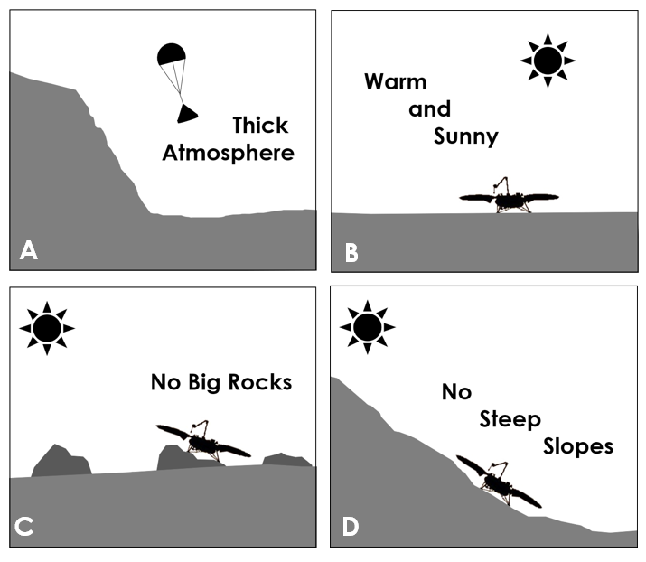

Figure 7-1: Some key rules for choosing a Martian landing site

A probe may enter the Martian atmosphere going as fast as 27,000 kph. Slowing it down for a soft landing requires a nice thick atmosphere (Figure 7-1 A). But the Martian atmosphere is thin; roughly one percent the density of Earth’s. To find enough of it to make a difference, you need to target the lowest elevations, where the air is denser and the flight through it takes as long as possible.

Unless you have a specialty probe—like one designed for a polar cap—you’ll want to land near the equator, where there’s plenty of sunshine for solar power and year-round temperatures are relatively warm (Figure 7-1 B). You’ll want to avoid sites covered in boulders that can destroy the probe, prevent its panels from opening, block its robotic arm, or leave it tilted away from the sun (Figure 7-1 C). For similar reasons, you’ll want to stay away from areas with steep slopes, such as found on the rims of craters (Figure 7-1 D). From a safety standpoint, flat and boring is beautiful.

Another issue with landing on Mars is that you can’t be very precise. It’s hard to fly fifty million kilometers or more, graze the atmosphere, and land on a dime. Inaccuracies in interplanetary navigation, along with variances in Martian atmospheric properties, make hitting a small target very uncertain.

Consequently, NASA runs lots of computer simulations for each landing coordinate. Key input variables, such as air density, are permitted to fluctuate across a range of expected values. Individual runs can have unique mixtures of properties, and even small changes may throw the landing off target.

Each simulation run produces a landing coordinate, and the resulting scatter of points from thousands of runs forms an elliptical shape with the long axis parallel to the flight path. These “landing ellipses” can be quite large (Figure 7-2), though accuracy improves with each new mission. The 2018 Insight lander had a landing ellipse of only 130 km x 27 km. The probability of the probe landing somewhere within that ellipse was on the order of 99%.

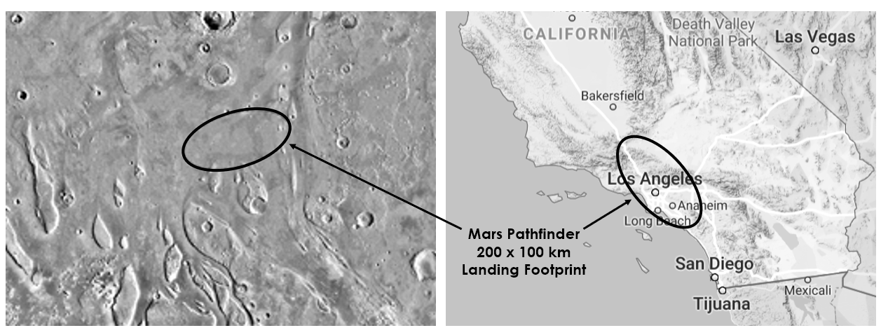

Figure 7-2: Scaled comparison of 1997 Mars Pathfinder landing site (left) with Southern California (right)

Each landing ellipse is carefully examined using high resolution images (Figure 7-3). In some cases, these images can detect individual boulders and even existing landers and rovers. Additional imaging techniques, such as radar, are used to identify other hazards, such as thick dust deposits. To evaluate multiple ellipses for each mission may require hundreds of people and years of workshops and reviews.

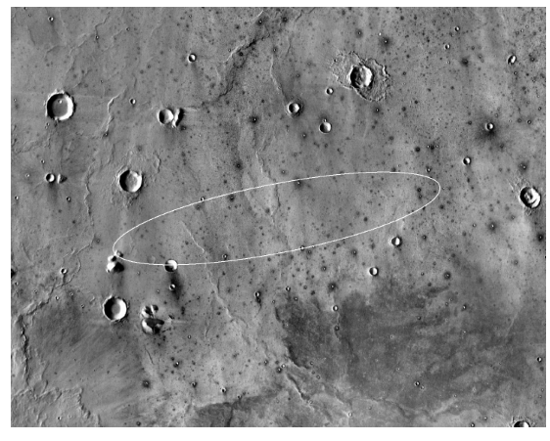

Figure 7-3: High resolution image of Mars Insight landing ellipse in Elysium Planitia (NASA-JPL/CalTech)

Winnowing through lots of potential landing sites is a hierarchical process. You need to rule out large areas before you start focusing on details. This calls for a first-pass filter, and there’s none better than the famous MOLA map.

The MOLA Map

For a small planet, Mars is surprisingly large. Despite being only half the size of Earth, it has almost the same amount of dry land (Figure 7-4). This startling fact is possible because Mars is a desert planet, while over 71% of Earth is covered by water. The sunny swath on Mars between 30o N latitude and 30o S latitude is larger than Asia and South America combined! To evaluate this much area in a short time, where do you even start?

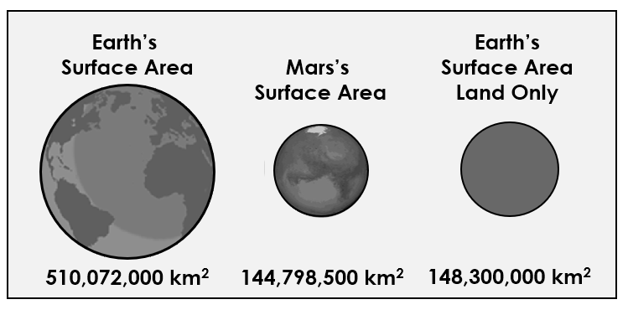

Figure 7-4: Comparison of surface areas and dry land areas on Earth and Mars

Fortunately, Mars is better mapped than the Earth, thanks to multiple orbiting probes, a thin atmosphere, no vegetative cover, and no surface water. Between 1997 and 2001, the Mars Orbiter Laser Altimeter tool aboard the Mars Global Surveyor shown (shined?) a laser on Mars and timed its reflection 600 million times. From these measurements, researchers led by Maria Zuber and David Smith produced a detailed global topography map known as MOLA (Figure 7-5).

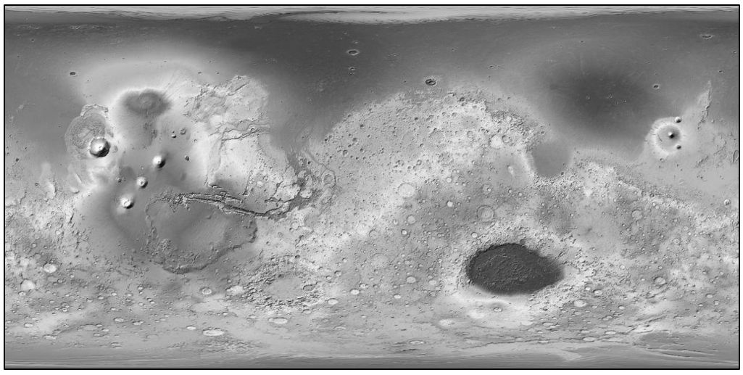

Figure 7-5: MOLA shaded relief map of Mars (courtesy of NASA)

To see the spectacular color version of MOLA, along with a legend, go to the Wikipedia page for the Mars Global Surveyor. The blues in this map correspond to where oceans and seas probably existed on Mars billions of years ago. Their distribution is based on a combination of elevation and diagnostic surface features, like ancient shorelines.

The laser measurements for MOLA have a vertical positional accuracy of around 3-13 m and a horizontal positional accuracy of about 100 m. Pixel resolution is 463 m per pixel. By itself, the MOLA map lacks the detail needed to safely choose a final landing ellipse, but it’s perfect for the scoping work you’ll be asked to do.

Project 10: Selecting Martian Landing Sites

Let’s pretend you’re a NASA summer intern working on the Orpheus Project, a lander designed to listen for marsquakes and study the interior of the planet, much like the 2018 Mars Insight mission.

Because the purpose of Orpheus is to study the interior of Mars, what’s on the surface is not that important. Safety is the prime concern, making this mission an engineer’s dream come true. Your job is to find twenty regions from which NASA staff can select candidate landing ellipses over the next year or two.

According to your supervisor, the regions should be rectangles 670 km long (E-W) and 335 km wide (N-S). The regions should conform to the guidelines shown in Figure 7-1:

* Straddle the equator between 30o N and 30o S latitude
* Lie at low elevations
* Be as smooth and flat as possible

begin box

The Objective

Write a Python program that uses an image of the Mars Orbiter Laser Altimeter map to choose the twenty safest 670 km x 335 km regions near the Martian equator from which to select landing ellipses for the Orpheus lander.

end box

Strategy

At this point, you know that you’re going to be using the MOLA digital map. You’ll need a way to divide it into rectangular regions and extract statistics on elevation and surface roughness. This means you’ll be working with pixels, so you’ll need imaging tools. And since NASA is always containing costs, you’ll want to use free, open source libraries, like OpenCV, the Python Imaging Library (PIL), tkinter, and NumPy. For an overview and installation instructions, see page XX in Chapter 1 for OpenCV and NumPy, and page XX in Chapter 3 for PIL. The tkinter module comes pre-installed with Python.

For honoring elevation constraints, you can simply calculate the average elevation for each region. For measuring how smooth a surface is at a given scale you have a lot of choices, some of them quite sophisticated. Besides looking at elevation data, you can look for differential shadowing in stereo images, the amount of scattering in radar, laser, and microwave reflections, thermal variations in infrared images, and so on. Many roughness estimates involve tedious analyses along transects, that is, lines drawn on the surface along which variations in height are measured and scrutinized. Since you’re not really a summer intern with three months to burn, you’re going to keep things simple and use two common measurements that you’ll apply to each rectangular region: standard deviation and peak-to-valley.

Standard deviation, also referred to as root-mean-square by physical scientists, is a measure of the spread in a set of numbers. A low standard deviation indicates the values in a set are close to the average value; a high standard deviation indicates they are spread out over a wider range. A map region with a low standard deviation for elevation means that the area is flattish, with little variance from the average elevation value.

Technically, the standard deviation for a population of samples is the square root of the average of the squared deviations from the mean, represented by the formula:

$$σ= \sqrt{\frac{1}{N}\sum_{i=1}^{N}{{(h_{i}-h_{0})}^{2}}}$$

where σ is the standard deviation, N is the number of samples, hi is the current height sample, and h0 is the mean of all the heights.

The peak-to-valley statistic is the difference in height between the highest and lowest points on a surface. It captures the maximum elevation change for the surface. If you’re hoping for a smooth flat surface, peak-to-valley represents the “worst case scenario” for that surface. This is important as a surface may have a relatively low standard deviation—suggesting smoothness—yet contain a significant hazard, as shown in the cross section in Figure 7-6.

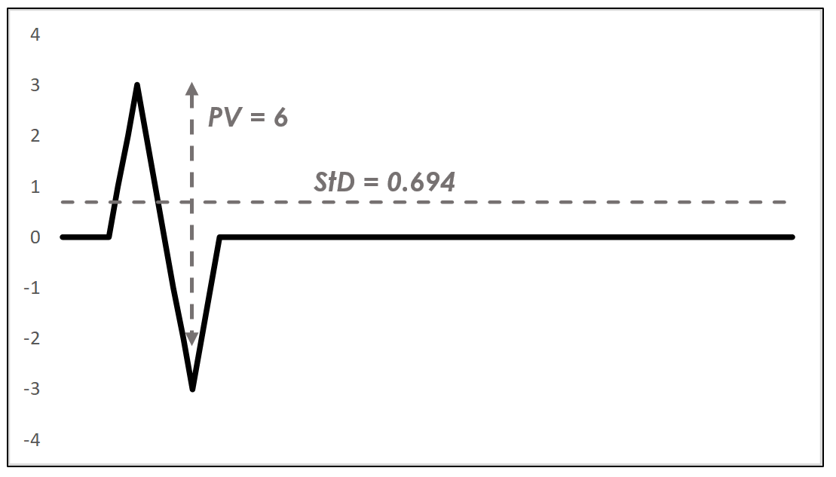

Figure 7-6: A surface profile (black line) with standard deviation (StD) and peak-to-valley (PV) statistics

You can use the standard deviation and peak-to-valley statistics as comparative metrics. The absolute values won’t matter as much as the relative values. For each rectangular region, you’re looking for the lowest values of each statistic. And because each statistic records something slightly different, you can find the best twenty rectangular regions for each, then select only the rectangles that overlap to find the very best rectangles, overall.

The Site Selector Code

The site_selector.py program uses a grayscale image of the MOLA map (Figure 7-7) to select the landing site rectangles and the shaded color map (Figure 7-5) to post them. Elevation is represented by a single channel in the grayscale image, so it’s easier to use than the three channel (RGB) color image.

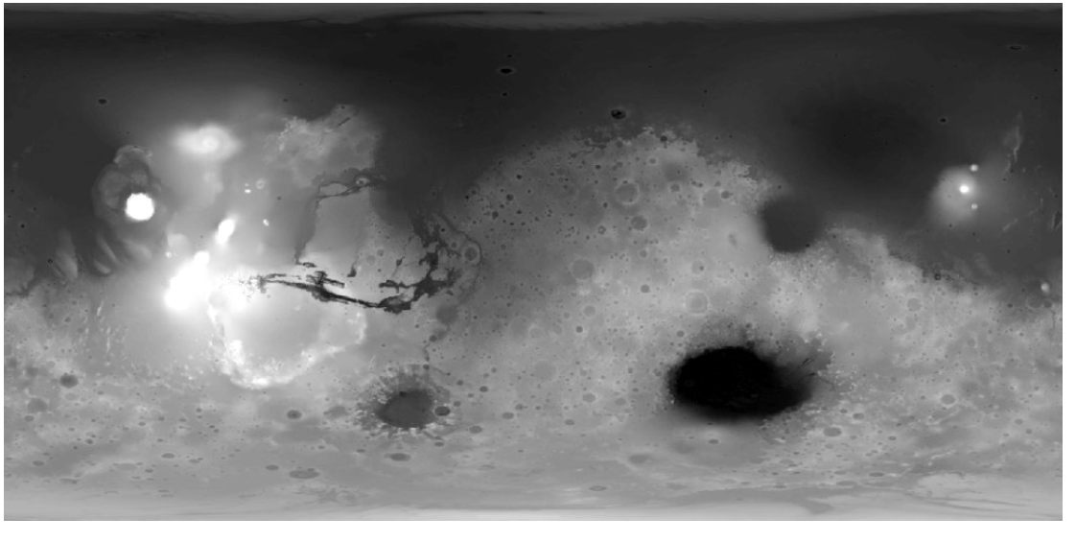

Figure 7-7: Mars MGS MOLA Digital Elevation Model 463m v2 (mola_1024x501.png)

You can find the program, the grayscale image (mola_1024x501.png), and the color image (mola_color_1024x506.png) in the Chapter_7 folder, downloadable from XXX. Keep these files together in the same folder and don’t rename them.

Note: The MOLA map comes in multiple file sizes and resolutions. You’re using the smallest size here to speed up the download and run times.

Importing Modules and Assigning User Input Constants

Listing 7-1 imports modules and assigns constants that represent user input parameters. These include image file names, the dimensions of the rectangular regions, a maximum elevation limit, and the number of candidate rectangles to consider.

➊import tkinter as tk

➋from PIL import Image, ImageTk

➌import numpy as np

import cv2 as cv

# CONSTANTS: User Input:

➍IMG_GRAY = cv.imread('mola_1024x501.png', cv.IMREAD_GRAYSCALE)

IMG_COLOR = cv.imread('mola_color_1024x506.png')

➎RECT_WIDTH_KM = 670 # Site rectangle width in kilometers.

RECT_HT_KM = 335 # Site rectangle height in kilometers.

➏MAX_ELEV_LIMIT = 55 # Intensity values (0-255).

➐NUM_CANDIDATES = 20 # Number of candidate landing regions to display.

MARS_CIRCUM = 21344 # Circumference in kilometers.

Listing 7-1: Imports modules and assigns user input constants, site_selector.py, Part 1

Start by importing the tkinter module ➊. This is Python’s default GUI library for developing desktop applications. You’ll use it to make the final display, which will be a window with the color MOLA map at the top and a text description of the posted rectangles at the bottom. Most Windows, macOS, and Linux machines come with tkinter already installed. If you don’t have it or need the latest version, you can download and install it from <https://www.activestate.com/>. Online documentation for the module can be found at <https://docs.python.org/3/library/tk.html>.

Next, import the Image and ImageTK modules from the Python Imaging Library ➋. The Image module provides a class with the same name which is used to represent a PIL image. The module also provides factory functions, including functions to load images from files, and to create new images. The second module contains support to create and modify Tkinter BitmapImage and PhotoImage objects from PIL images. Again, you’ll use these at the end to place the color map and some descriptive text in a summary window.

Finish the imports with NumPy and OpenCV ➌.

Now, assign some constants that represent user input that won’t change as the program runs. First, use the OpenCV imread() method to load the grayscale MOLA image ➍. Note that you have to use the flag cv.IMREAD_GRAYSCALE, as the default is cv.IMREAD_COLOR. Repeat the code without the flag to load the color image.

Add constants for the rectangle size, which according to your supervisor should be 670 km x 335 km ➎. In the next listing, you’ll convert these dimensions to pixels for use with the map image.

Next, to ensure the rectangles target smooth areas at low elevations, you should limit the search to the lightly cratered, flat lying terrain believed to represent old ocean bottoms. Thus, you’ll want to set the maximum elevation limit to a grayscale value of 55 ➏, which corresponds closely to the postulated remnants of ancient shorelines (see Figure 7-8).

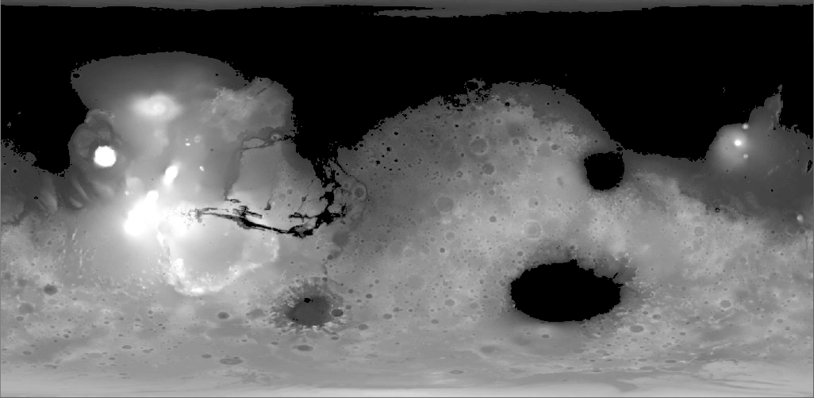

Figure 7-8: MOLA map with pixel values < 55 colored black to represent ancient Martian oceans.

Now, specify the number of rectangles to display ➐. Later, you’ll select these from a sorted list of rectangle statistics. Complete the user input constants by assigning a constant to hold the Martian circumference, in kilometers. You’ll use this later to determine the number of pixels per kilometer.

Assigning Derived Constants and Creating the Screen Object

Listing 7-2 assigns constants that are derived from other constants. These are constants that the user shouldn’t need to edit if they repeatedly use the program, for example, to test out different rectangle sizes or elevation limits. The listing ends by creating tkinter screen and canvas objects for the final display.

# CONSTANTS: Derived and fixed:

➊IMG_HT, IMG_WIDTH = IMG_GRAY.shape

➋PIXELS_PER_KM = IMG_WIDTH / MARS_CIRCUM

➌ RECT_WIDTH = int(PIXELS_PER_KM * RECT_WIDTH_KM)

RECT_HT = int(PIXELS_PER_KM * RECT_HT_KM)

➍ LAT_30_N = int(IMG_HT / 3)

LAT_30_S = LAT_30_N * 2

➎STEP_X = int(RECT_WIDTH / 2)

➏STEP_Y = int(RECT_HT / 2)

# Create tkinter screen and drawing canvas

➐screen = tk.Tk()

➑canvas = tk.Canvas(screen, width=IMG_WIDTH, height=IMG_HT + 130)

Listing 7-2: Assigns derived and fixed constants, site_selector.py, Part 2

Start by unpacking the height and width of the image using the shape attribute ➊. OpenCV stores images as NumPy ndarrays, and shape is a tuple of the number of rows, columns, and channels. Height represents the number of pixel rows in the image and width represents the number of pixel columns in the image. Channels represent the number of components used to represent each pixel (such as, red, green, and blue). For grayscale images with one channel, shape is just a tuple of row (height) and column (width).

To convert the rectangle dimensions from kilometers to pixels, you need to know how many pixels there are per kilometer. So, divide the image width by the circumference to get the pixels per kilometer at the equator ➋. Then convert width ➌ and height into pixels. You’ll use these to derive values for index slicing later, so make sure they are integers by using int(). The value of these constants should now be 32 and 16, respectively.

You want to limit your search to the warmest and sunniest areas which straddle the equator between 30o North latitude and 30o South latitude (Figure 7-9). This corresponds to what is loosely referred to as the tropics on Earth, based on climatic criteria.

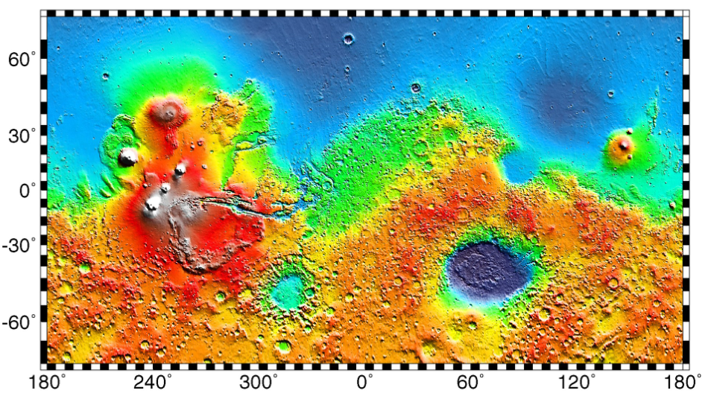

Figure 7-9: Latitude (y-axis) and longitude (x-axis) on Mars (Wikimedia Commons)

Latitude values start at 0o at the equator and end at 90o at the poles. To find 30o North, all you need to do is divide the image height by three ➍. To get 30o South, double the number of pixels it took to get to 30o North.

Restricting the search to the equatorial region of Mars has a beneficial side-effect. The MOLA map you’re using is based on a Cylindrical Projection, used to transfer the surface of a globe onto a flat plane. This causes converging lines of longitude to be parallel, badly distorting features near the poles. You may have noticed this on wall maps of the Earth, where Greenland looks like a continent and Antarctica is impossibly huge (see Figure 7-10).

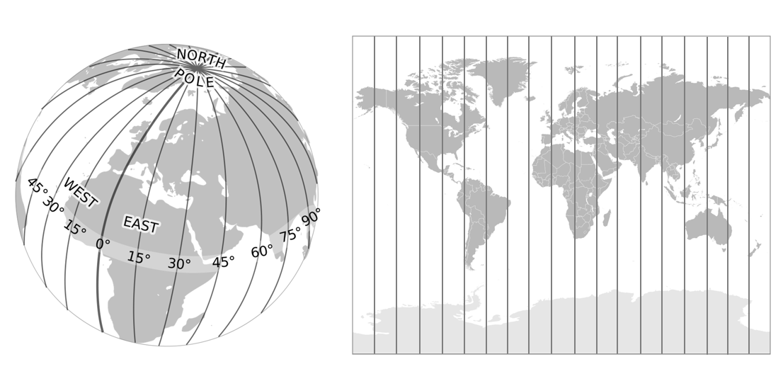

Figure 7-10: Forcing lines of longitude to be parallel distorts the size of features near the poles (courtesy Wikimedia Commons)

Fortunately, this distortion is minimized near the equator, so you don’t have to factor it into the rectangle dimensions. You can verify this by checking the shape of craters on the MOLA map. So long as they’re nice and circular—rather than oval—projection-related effects can be ignored.

You’ll need to divide the map up into rectangular regions. A logical place to begin is the upper left corner, tucked under the 30o North latitude line (Figure 7-11).

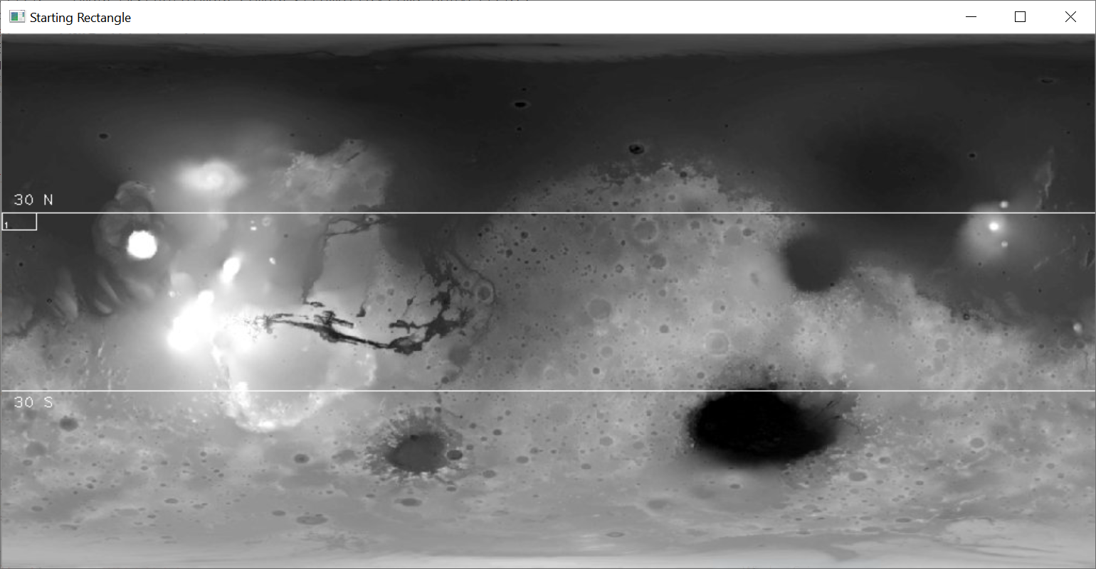

Figure 7-11: Position of the first rectangle

The program will draw this first rectangle, number it, and calculate the elevation statistics within it. It will then move the rectangle eastward and repeat the process. How far you move the rectangle each time is defined by the STEP_X ➎ and STEP_Y ➏ constants and depends on something called aliasing.

Aliasing is a resolution issue that occurs when sampling frequency is insufficient to identify important surface features. For example, in Figure 7-12A, a suitably smooth landing ellipse can be found between two large craters. As laid out in Figure 7-12B, no rectangular region captures this ellipse; both rectangles in the vicinity partially sample a crater rim, resulting in “rough” statistics unsuitable for a landing. With this arrangement of rectangles, the ellipse is aliased. But shift each rectangle by half its width, as in Figure 7-12C, and the smooth area is properly sampled and recognized.

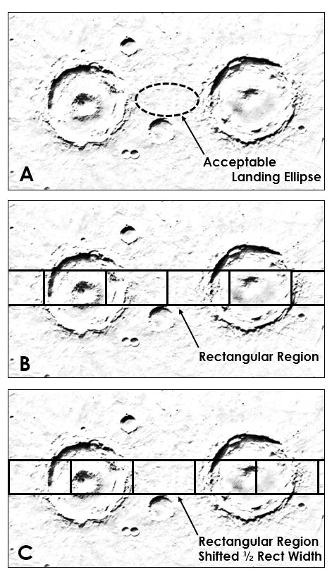

Figure 7-12: Example of aliasing due to rectangle positioning (photo courtesy of NASA)

The rule of thumb to avoid aliasing effects is to make the step size less than or equal to half the width of the smallest feature you want to identify. For this project, use half the rectangle width so the displays don’t become too busy ➎➏.

Now it’s time to look ahead to the final display. Create a screen instance of the tkinter Tk()class ➐. The tkinter application is a thin object-oriented layer on top of the Tool Command Language (tcl), and it needs this window to link to an underlying tcl/tk interpreter that translates tkinter commands into tcl/tk commands.

Next, create a tkinter canvas object ➑. This is a rectangular drawing area designed for complex layouts of graphics, text, widgets, and frames. Pass it the screen object, set its width equal to the MOLA image, and its height equal to the height of the MOLA image plus 130. The extra padding beneath the image will hold the text summarizing the statistics for the displayed rectangles.

It’s more typical to place the tkinter code just described at the end of programs, rather than at the beginning. I chose to put it near the top to make the code explanation easier to follow. You can also embed this code within the function that makes the final display, however, this can cause problems for macOS users. For macOS 10.6 or later, the Apple-supplied Tcl/Tk 8.5 has serious bugs that can cause application crashes (see <https://www.python.org/download/mac/tcltk/>).

Defining and Initializing a Search Class

Python is an object-oriented programming language, but it doesn’t force you to use the OOP paradigm. Because it also supports procedural programming, you can mix and match, choosing the simplicity of modules and functions for part of your program and the greater sophistication of objects for the rest. For a quick overview of OOP, see Page XX in Chapter 1, where you also define a search class.

Listing 7-3 defines a class that you’ll use to search for suitable rectangular regions. It then defines the __init__() initialization method for the class, used to instantiate (create) new objects. This method lets you create, or bind, the attributes of each newly created instance of the class. An attribute is a named value associated with an object. If your object is a person, an attribute might be her weight or eye color. Although it’s possible to bind attributes to an instance outside of __init__(), your code will be more readable and updatable if you restrict all bindings to this method.

➊class Search():

"""Read image and identify landing rectangles based on input criteria."""

➋def __init__(self, name):

➌self.name = name

➍self.rect_coords = {}

self.rect_means = {}

self.rect_ptps = {}

self.rect_stds = {}

➎self.ptp_filtered = []

self.std_filtered = []

➏self.high_graded_rects = []

Listing 7-3: Defines the Search class and __init__() method, site_selector.py (Part 3)

You’re no doubt familiar with built-in data types in Python, such as lists and dictionaries. OOP lets you define your own type, using class(). A class is a user defined prototype for creating objects. It contains the set of properties and methods that are common to all objects of that type. Here, you’ll define a class called Search ➊.

Next, define the __init__() method used to create new objects ➋. Instance methods must have a special first parameter, called self by convention. Methods will use this parameter to refer to the object itself. Without it, the program couldn’t track and manage multiple objects of the same type. The name parameter will allow you to give a personalized name to each object when you create it later in the main() function.

Now you’re ready to start assigning attributes. Start by linking the object’s name with the argument you’ll provide when you create the object ➌. Then assign some empty dictionaries to hold important statistics for each rectangle ➍. These will be the corner-point coordinates of the rectangle and its mean elevation, peak-to-valley, and standard deviation statistics. For a key, these dictionaries will use consecutive numbers, starting with one. The corresponding value will be the corner coordinates or the statistics.

You’ll want to filter the statistics to find the lowest values, so set-up two empty lists to hold these ➎. Note that I use “ptp”, rather than “ptv”, for the peak-to-valley statistic. That’s to be consistent with the NumPy built-in method for this calculation, which is called “peak-to-peak.”

At the end of the program, you’ll find the overlapping rectangles between the sorted standard deviation and peak-to-valley lists and place them in a new list named high_graded_rects ➏. This will be a list of rectangle numbers representing rectangles with the lowest combined scores. These will be the best places to look for landing ellipses.

Calculating Rectangle Statistics

Listing 7-4, still in the Search class, defines a method for calculating statistics in a rectangle, adding the statistics to the appropriate dictionary, and then moving the rectangle. The elevation limit is honored so that only rectangles in low-lying areas are used to populate the dictionaries.

➊def run_rect_stats(self):

"""Define rectangular search areas and calculate internal stats."""

➋ul_x, ul_y = 0, LAT_30_N

lr_x, lr_y = RECT_WIDTH, LAT_30_N + RECT_HT

➌rect_num = 1

➍while True:

➎rect_img = IMG_GRAY[ul_y : lr_y, ul_x : lr_x]

➏self.rect_coords[rect_num] = [ul_x, ul_y, lr_x, lr_y]

➐if np.mean(rect_img) <= MAX_ELEV_LIMIT:

self.rect_means[rect_num] = np.mean(rect_img)

self.rect_ptps[rect_num] = np.ptp(rect_img)

self.rect_stds[rect_num] = np.std(rect_img)

➑rect_num += 1

# Move the rectangle.

ul_x += STEP_X

lr_x = ul_x + RECT_WIDTH

➒if lr_x > IMG_WIDTH:

ul_x = 0

ul_y += STEP_Y

lr_x = RECT_WIDTH

lr_y += STEP_Y

➓if lr_y > LAT_30_S + STEP_Y:

break

Listing 7-4: Calculates rectangle statistics and moves the rectangle, site_selector.py (Part 4)

Define the run_rect_stats() method that takes self as an argument ➊. Then assign local variables for the upper left and lower right corners of each rectangle, initializing them using a combination of coordinates and constants ➋. This will place the first rectangle along the left side of the image with its top boundary coincident with 30o North latitude (see Figure 7-11).

Use a numbering system starting with one to keep track of the rectangles ➌. These numbers will serve as the keys for the dictionaries used to record coordinates and stats. You’ll also use them to identify the rectangles on the map, as demonstrated in Figure 7-11.

Now, start a while loop that will automate the process of moving the rectangles and recording their statistics ➍. This loop will run until more than half of a rectangle extends below latitude 30o South, at which time the loop will break.

As mentioned previously, OpenCV stores images as NumPy arrays. To calculate the stats within the active rectangle, rather than the whole image, create a subarray using normal slicing ➎. Call this subarray rect_img, for “rectangular image.” Then, add the rectangle number and these coordinates to the rect_coords dictionary ➏. You’ll want to keep a record of these for the NASA staff, who’ll use your rectangles as the starting point for more detailed investigations later.

Next, start a conditional to check that the current rectangle is at or below the maximum elevation limit specified for the project ➐. As part of this statement, use NumPy to calculate the mean elevation for the rect_img subarray.

If the rectangle passes the elevation test, populate the three dictionaries with the coordinates, peak-to-valley, and standard deviation statistics, as appropriate. Note that you can perform the calculation as part of the process, using np.ptp for peak-to-valley and np.std for standard deviation.

Next, advance the rect_num variable by one ➑ and move the rectangle. Move the upper left x-coordinate by the step size, then shift the lower right x-coordinate by the width of the rectangle. You don’t want the rectangle to extend off the right side of the image, so check to see if lr_x is greater than the image width ➒. If it is, set the upper left x-coordinate to 0, to move the rectangle back to the starting position on the left side of the screen, and move its y-coordinates down so that the new rectangles move along a new row. If the bottom of this new row is more than half a rectangle height below 30o South latitude, you’ve fully sampled the search area and can end the loop ➓.

The way we’re handling rectangles moving off the image is an example of fit-for-purpose design. Because the rectangle width divides evenly into the image width (1024/32 = 32), you don’t have to worry about wrapping the rectangles from one side to the other. Although you can’t take the final step that shifts the rectangle by one half its width, it doesn’t matter. Between 30o North and South latitude, the image is bounded on both sides by relatively high, cratered terrain not suitable for a landing site (see Figure 7-9). In the challenge projects at the end of the chapter, you’ll get a chance to wrap a rectangle around the edge of the image.

Note: When you draw something on an image, such as a rectangle, the drawing becomes part of the image. The altered pixels will be included in any NumPy analyses you run, so be sure to calculate any statistics before you annotate the image.

Checking the Rectangle Locations

Listing 7-5, still indented under the Search class, defines a method to print the coordinates of all the rectangles and then draw them on the MOLA map as a quality control step. This will let you verify that the search area has been fully evaluated and the rectangle size is as expected.

➊def draw_qc_rects(self):

"""Draw overlapping search rectangles on image as a check."""

➋img_copy = IMG_GRAY.copy()

➌rects_sorted = sorted(self.rect_coords.items(), key=lambda x: x[0])

➍for k, v in rects_sorted:

print("rect: {}, coords (ul_x, ul_y, lr_x, lr_y): {}".format(k, v))

➎cv.rectangle(img_copy,

(self.rect_coords[k][0], self.rect_coords[k][1]),

(self.rect_coords[k][2], self.rect_coords[k][3]),

(255, 0, 0), 1)

➏cv.imshow('QC Rects {}'.format(self.name), img_copy)

➐cv.waitKey(3000)

cv.destroyAllWindows()

Listing 7-5: Draws all the rectangles on the MOLA map as a quality control step, site_selector.py (Part 5)

Start by defining a method to draw the rectangles on the image ➊. Things you draw on an image in OpenCV become part of the image, so first make a copy of the image in the local space ➋.

You’ll want to print each rectangle’s coordinates in order of rectangle number, but dictionaries are unordered. To remedy this, sort the items in the rect_coords dictionary using a lambda function ➌. If you haven’t used lambda before, you can find a short description on Page XX in Chapter 5.

Start a for loop through the keys and values in the newly sorted dictionary ➍. The key is the rectangle number, and the value is the list of coordinates. Be sure to include a descriptor of the coordinates in the printout, so you know which corner point is being referenced in the list:

rect: 1, coords (ul_x, ul_y, lr_x, lr_y): [0, 167, 32, 183]

rect: 2, coords (ul_x, ul_y, lr_x, lr_y): [16, 167, 48, 183]

—snip—

rect: 1259, coords (ul_x, ul_y, lr_x, lr_y): [976, 319, 1008, 335]

rect: 1260, coords (ul_x, ul_y, lr_x, lr_y): [992, 319, 1024, 335]

Use the OpenCV rectangle() method to draw the rectangles on the image ➎. Pass it the image on which to draw, the rectangle coordinates, a color, and a line width. Access the coordinates directly from the rect_coords dictionary, using the key and the list index corresponding to the proper corner point coordinate.

To display the image, call the OpenCV imshow() method and pass it a name for the window and the image variable ➏. The rectangles should cover Mars in a band centered on the equator (Figure 7-13). Leave the window up for three seconds ➐, then destroy it.

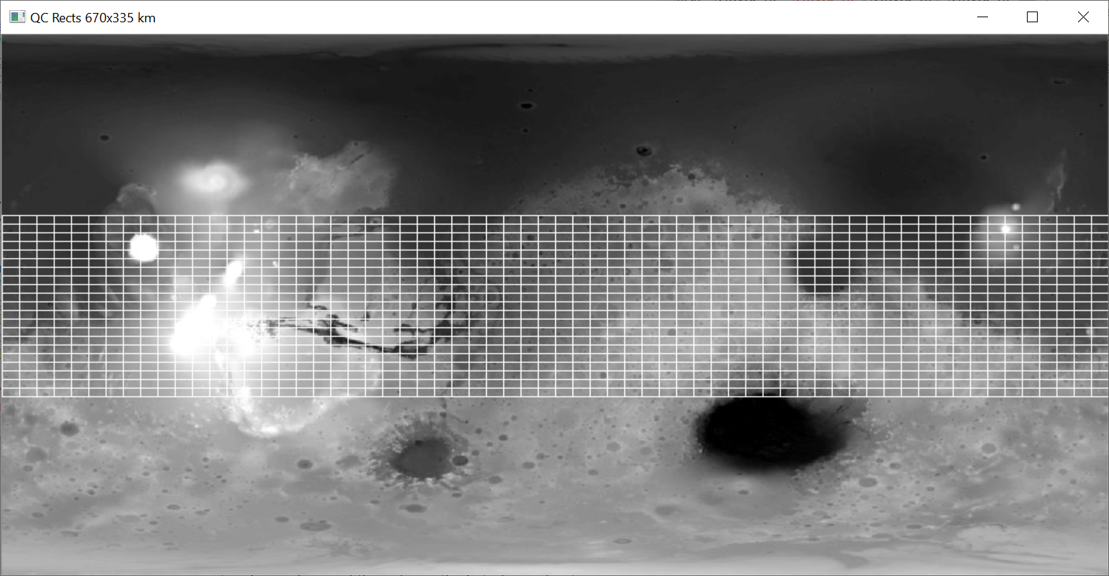

Figure 7-13: All 1,260 rectangles drawn on the MOLA image by the draw_qc_rects() method

You may notice that the rectangles appear smaller than expected (compare Figure 7-13 to Figure 7-11). This is because the rectangles have been stepped across and down the image using half the rectangle width and height and are thus overlapping each other.

Sorting the Statistics and High Grading the Rectangles

Listing 7-6, still indented under the Search class, defines a method to sort the dictionaries containing the rectangle statistics, make a list of the top rectangles based on peak-to-valley and standard deviation, and make a list of any rectangles shared between these two lists. The shared rectangles will be the best candidates for landing sites as both their peak-to-valley and standard deviation stats are minimized.

➊def sort_stats(self):

"""Sort dictionaries by values and create lists of top N keys."""

➋ptp_sorted = (sorted(self.rect_ptps.items(), key=lambda x: x[1]))

➌self.ptp_filtered = [x[0] for x in ptp_sorted[:NUM_CANDIDATES]]

std_sorted = (sorted(self.rect_stds.items(), key=lambda x: x[1]))

self.std_filtered = [x[0] for x in std_sorted[:NUM_CANDIDATES]]

# Make list of rects where filtered std & ptp coincide.

➍for rect in self.std_filtered:

if rect in self.ptp_filtered:

self.high_graded_rects.append(rect)

Listing 7-6: Sorts and high grades the rectangles based on their statistics, site_selector.py (Part 6)

Define a method called sort_stats() ➊. Sort the rect_ptps dictionary with a lambda function that uses the values, rather than the keys ➋. The values in this dictionary are the peak-to-valley measurements. The result is a list of tuples, with the rectangle number at index 0 and the peak-to-valley value at index 1.

Next, use list comprehension to populate the self.ptp_filtered attribute with the rectangle numbers in the ptp_sorted list ➌. Use index slicing to select only the first twenty values, as stipulated by the NUM_CANDIDATES constant. You now have the twenty rectangles with the lowest peak-to-valley scores. Repeat this same basic code for standard deviation, producing a list of the twenty rectangles with the lowest standard deviation.

Finish the method by looping through the rectangle numbers in the std_filtered list and comparing them to those in the ptp_filtered list ➍. Append matching numbers to the high_graded_rects instance attribute you created previously with the __init__() method.

Drawing the Filtered Rectangles on the Map

Listing 7-7, still indented under the Search class, defines a method to draw the filtered rectangles and the 30o latitude limits on an image. You’ll call this method in the main() function to post the twenty best rectangles, based on peak-to-valley or standard deviation, on the grayscale MOLA map.

➊def draw_filtered_rects(self, image, filtered_rect_list):

"""Draw rectangles in list on image and return image."""

➋img_copy = image.copy()

➌for k in filtered_rect_list:

➍cv.rectangle(img_copy,

(self.rect_coords[k][0], self.rect_coords[k][1]),

(self.rect_coords[k][2], self.rect_coords[k][3]),

(255, 0, 0), 1)

➎cv.putText(img_copy, str(k),

(self.rect_coords[k][0] + 1, self.rect_coords[k][3]- 1),

cv.FONT_HERSHEY_PLAIN, 0.65, (255, 0, 0), 1)

# Draw latitude limits.

➏cv.putText(img_copy, '30 N', (10, LAT_30_N - 7),

cv.FONT_HERSHEY_PLAIN, 1, 255)

➐cv.line(img_copy, (0, LAT_30_N), (IMG_WIDTH, LAT_30_N),

(255, 0, 0), 1)

cv.line(img_copy, (0, LAT_30_S), (IMG_WIDTH, LAT_30_S),

(255, 0, 0), 1)

cv.putText(img_copy, '30 S', (10, LAT_30_S + 16),

cv.FONT_HERSHEY_PLAIN, 1, 255)

➑return img_copy

Listing 7-7: Draws filtered rectangles and latitude lines on MOLA map, site_selector.py (Part 7)

Start by defining the method, which in this case takes multiple arguments ➊. Besides self, the method will need a loaded image and a list of rectangle numbers.

Use a local variable to copy the image ➋ and then start looping through the rectangle numbers in the filtered_rect_list ➌. With each loop, draw a rectangle, using the rectangle number to access the corner coordinates in the rect_coords dictionary ➍.

So you can tell one rectangle from another, use OpenCV’s putText() method to post the rectangle number in the bottom left corner ➎. It needs the image, the text (as a string), coordinates for upper left x and lower right x, a font, line width, and color.

Next, draw the annotated latitude limits, starting with the text for 30o N ➏. Then draw the line using OpenCV’s line() method ➐. It takes as arguments an image, a pair of (x, y) coordinates for the start and end of the line, a color, and a thickness. Repeat these basic instructions for 30o S latitude.

End the method by returning the annotated image ➑.

The output for the peak-to-valley and standard deviation statistics are shown in Figures 7-14 and 7-15, respectively.

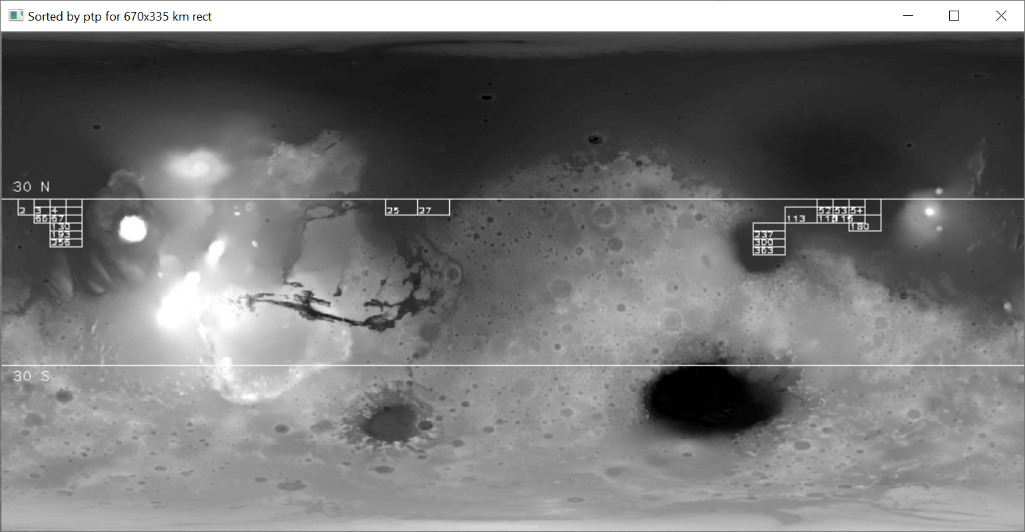

Figure 7-14: The twenty rectangles with the lowest peak-to-valley scores

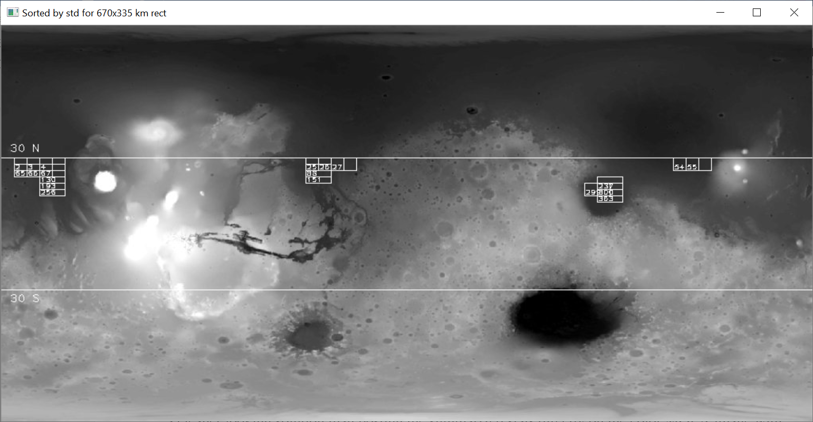

Figure 7-15: The twenty rectangles with the lowest standard deviations

Making the Final Color Display

Listing 7-8 finishes the Search class by defining a method to summarize the best rectangles. It uses tkinter to make a summary window with the rectangles posted on the color MOLA image and their statistics printed below as text objects. This adds a little work but it’s a cleaner looking solution than posting the summarized stats directly on the image with OpenCV.

def make_final_display(self):

"""Use Tk to show map of final rects & printout of their statistics."""

➊screen.title('Sites by MOLA Gray STD & PTP {} Rect'.format(self.name))

# Draw the high-graded rects on the colored elevation map.

➋img_color_rects = self.draw_filtered_rects(IMG_COLOR,

self.high_graded_rects)

# Convert image from CV BGR to RGB for use with Tkinter.

➌img_converted = cv.cvtColor(img_color_rects, cv.COLOR_BGR2RGB)

➍img_converted = ImageTk.PhotoImage(Image.fromarray(img_converted))

➎canvas.create_image(0, 0, image=img_converted, anchor=tk.NW)

# Add stats for each rectangle at bottom of canvas.

➏txt_x = 5

txt_y = IMG_HT + 20

➐for k in self.high_graded_rects:

canvas.create_text(txt_x, txt_y, anchor='w', font=None,

text="rect={} mean elev={:.1f} std={:.2f} ptp={}"

.format(k, self.rect_means[k], self.rect_stds[k],

self.rect_ptps[k]))

txt_y += 15

➑if txt_y >= int(canvas.cget('height')) - 10:

txt_x += 300

txt_y = IMG_HT + 20

➒canvas.pack()

screen.mainloop()

Listing 7-8: Makes the final display using the color MOLA map, site_selector.py (Part 8)

After defining the method, give the tkinter screen window a title that links to the name of your search object ➊.

Then, to make the final color image for display, name a local variable img_color_rects and call the draw_filtered_rects() method ➋. Pass it the color MOLA image and the list of high-graded rectangles. This will return the colored image with the final rectangles and latitude limits posted.

Before you can post this new color image in the tkinter canvas, you need to convert the colors from OpenCV’s Blue-Green-Red (BGR) format to the Red-Green-Blue (RGB) format used by tkinter. Do this with the OpenCV cvtColor() method, passing it the image variable and the COLOR_BGR2RGB flag ➌. Name the result img_converted.

At this point, the image is still a NumPy array. To convert to a tkinter-compatible photo image, you need to use the PIL ImageTk module’s PhotoImage class and the Image module’s fromarray() method ➍. Pass the method the RGB image variable you created in the previous step.

With the image finally tkinter-ready, place it in the canvas using the create_image() method ➎. Pass the method the coordinates where you want the upper left corner of the canvas (0, 0), the converted image, and a northwest anchor direction.

Now all that’s left is to add the summary text. Start by assigning coordinates for the bottom left corner of the first text object ➏. Then begin looping through the rectangle numbers in the high-graded rectangle list ➐. Use the create_text() method to place the text in the canvas. Pass it a pair of coordinates, a left-justified anchor direction, the default font, and a text string. Note that you can use the new style string formatting, and you get the actual statistics by accessing the different dictionaries using the rectangle number designated as k, for “key.”

Increment the text box’s y coordinate by 15 after drawing each text object, followed by a conditional to check that the text is greater than or within 10 pixels of the bottom of the canvas ➑. You can obtain the height of the canvas using the cget() method.

If the text is too close to the bottom of the canvas, you need to start a new column. Shift the txt_x variable over by 300 and reset txt_y to the image height plus 20.

Finish the method definition by packing the canvas ➒ and then calling the screen object’s mainloop(). Packing optimizes the placement of objects in the canvas. The mainloop() is an infinite loop used to run tkinter, wait for an event to occur, and process the event until the window is closed.

Note: The height of the color image (506 pixels) is slightly larger than that for the grayscale image (501 pixels). I chose to ignore this but if you’re a stickler for accuracy, you can use OpenCV to shrink the height of the color image using IMG_COLOR = cv.resize(IMG_COLOR, (1024, 501), interpolation = cv.INTER_AREA).

Running the Program with main()

Listing 7-9, back in the global space, defines a main() function to run the program.

def main():

➊app = Search('670x335 km')

➋app.run_rect_stats()

➌app.draw_qc_rects()

➍app.sort_stats()

➎ptp_img = app.draw_filtered_rects(IMG_GRAY, app.ptp_filtered)

std_img = app.draw_filtered_rects(IMG_GRAY, app.std_filtered)

# Display filtered rects on grayscale map.

➏cv.imshow('Sorted by ptp for {} rect'.format(app.name), ptp_img)

cv.waitKey(3000)

cv.imshow('Sorted by std for {} rect'.format(app.name), std_img)

cv.waitKey(3000)

➐app.make_final_display() # Includes call to mainloop().

➑if __name__ == '__main__':

main()

Listing 7-9: Defines and calls the main() function used to run the program, site_selector.py (Part 9)

One reason Python is so popular is that its code is easy to read. That’s the case with the main() function, which reads a lot like pseudocode.

Start by instantiating an app object from the Search class ➊. Name it 670x335 km, to document the size of the rectangular regions being investigated.

Next, call the Search methods in order. Run the stats on the rectangles ➋, draw the quality control rectangles ➌, sort the statistics from smallest to largest ➍, draw the filtered rectangles for peak-to-valley ➎ and standard deviation and show the results ➏. Finish the function by making the final summary display ➐.

Back in the global space, add the code that lets the program run as an imported module or in stand-alone mode ➑.

Figure 7-16 is the final display with the high-graded rectangles posted and the summary statistics sorted on standard deviation.

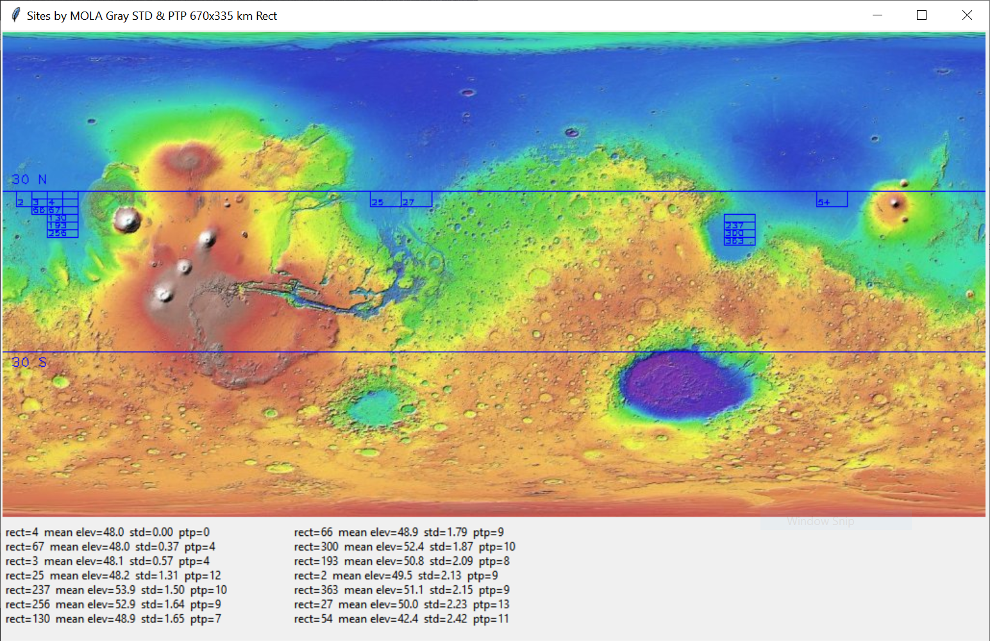

Figure 7-16: Final display with high-graded rectangles and summary statistics sorted by standard deviation

Results

After making the final display, the first thing you want to do is perform a sanity check. Make sure the rectangles are within the latitude and elevation limits and appear to be in smooth terrain. Likewise, the output for the peak-to-valley and standard deviation statistics, shown in Figures 7-14 and 7-15, respectively, should match the constraints and broadly agree.

If you look carefully, you’ll notice that the rectangles in Figures 7-14 and 7-15 don’t perfectly overlap. That’s because you’re using two different metrics for smoothness. One thing you can be sure of, though, is that the rectangles that overlap will be the smoothest overall.

While all the rectangle locations look reasonable in the final display, the concentration of rectangles on the far west side of the map is particularly encouraging. This is the smoothest terrain in the search area, and your program clearly recognized it (Figure 7-17).

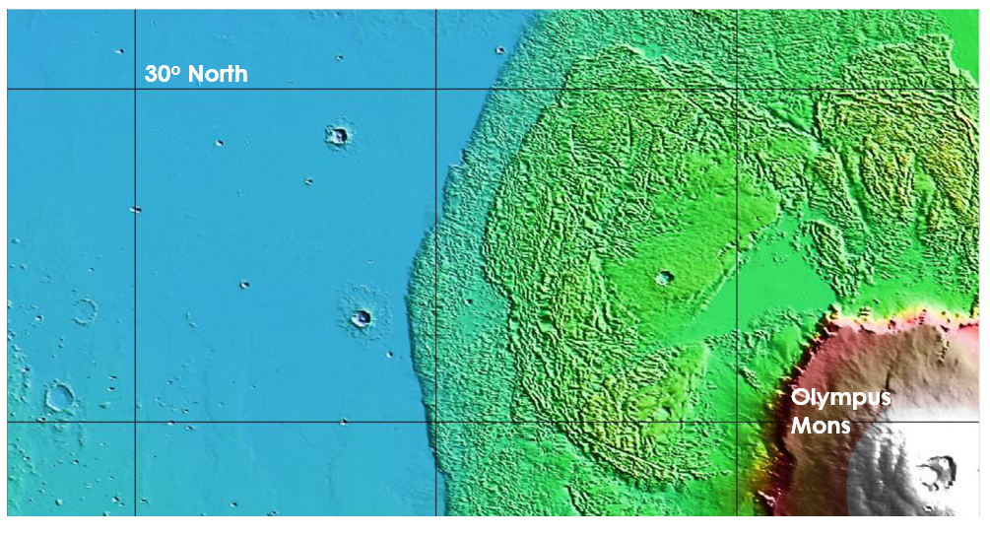

Figure 7-17: The very smooth terrain west of the Olympus Mons lava fields

This project focused on safety concerns, but scientific objectives drive site selection for most missions. In the practice projects at the end of the chapter, you’ll get a chance to incorporate an additional constraint—geology—into the site selection equation.

Summary

In this chapter, you used Python, OpenCV, the Python Imaging Library, NumPy, and tkinter to load, analyze, and display an image. Because OpenCV treats images as NumPy arrays, you can easily extract information from parts of an image and evaluate it with Python’s many scientific libraries.

The dataset you used was quick to download and fast to run. While a real intern would’ve used a larger and more rigorous dataset, such as one comprised of actual elevation measurements, you got to see how the process works with little effort and very reasonable results.

Further Reading

The Jet Propulsion Laboratory has several short and fun videos about landing on Mars. Just do an online search for “Mars in a Minute: How Do You Choose a Landing Site?”, “Mars in a Minute: How Do You Get to Mars?”, and “Mars in a Minute: How Do You Land on Mars?”

Mapping Mars: Science, Imagination, and the Birth of a World (Picador, 2002) by Oliver Morton, tells the story of the contemporary exploration of Mars by instruments, including the creation of the MOLA map.

The Atlas of Mars: Mapping its Geography and Geology (Cambridge University Press, 2019) by Kenneth Coles, Kenneth Tanaka, and Philip Christensen, is a spectacular all-purpose reference atlas of Mars that includes maps of topography, geology, mineralogy, thermal properties, near-surface water-ice, and more.

The data page for the MOLA map used in Project 10 can be found at <https://astrogeology.usgs.gov/search/map/Mars/GlobalSurveyor/MOLA/Mars_MGS_MOLA_DEM_mosaic_global_463m>.

Detailed Martian datasets can be found at the Mars Orbital Data Explorer site produced by the PDS Geoscience Node at Washington University in St. Louis (<https://ode.rsl.wustl.edu/mars/index.aspx>).

Practice Project: Confirming that Drawings Become Part of an Image

Write a Python program that verifies that drawings added to an image, such as text, lines, rectangles, and so on, become a part of that image. Use NumPy to calculate the mean, standard deviation, and peak-to-valley on a rectangular region in the MOLA grayscale image, but don’t draw the rectangle. Then draw a white outline around the region and rerun the stats.

You can find a solution, practice_confirm_drawing_part_of_image.py, in the Appendix or in the Chapter_7 folder downloadable from https/XXXXX.

Practice Project: Mixing Maps

Make up a new project where you add a bit of science to the site selection process. Combine the MOLA map with a color geology map and find the smoothest rectangular regions within the volcanic deposits at Tharsis Montes (see arrow in Figure 7-18).

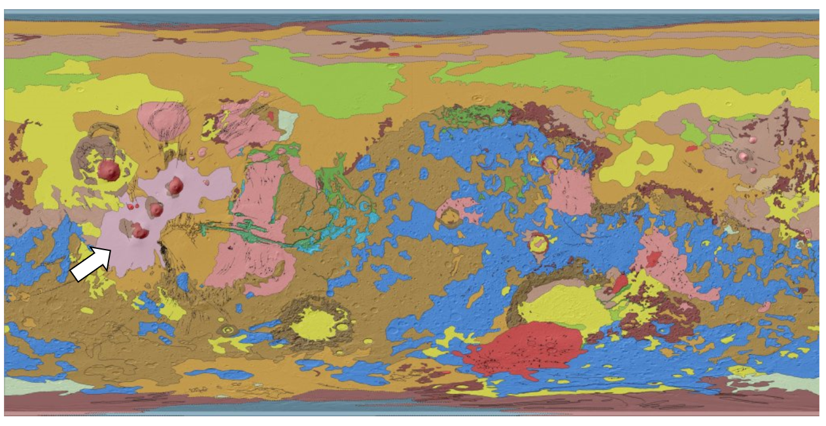

Figure 7-18: Geological map of Mars. The arrow points to volcanic deposits on Tharsis Montes.

Since the Tharsis Montes region lies at a high altitude, focus on finding the flattest and smoothest parts of the volcanic deposits, rather than targeting the lowest elevations. But be careful, as the geological map contains shading and boundary lines that will show up in your statistics. Consider thresholding the map and using it to filter the MOLA map, as shown in Figure 7-19.

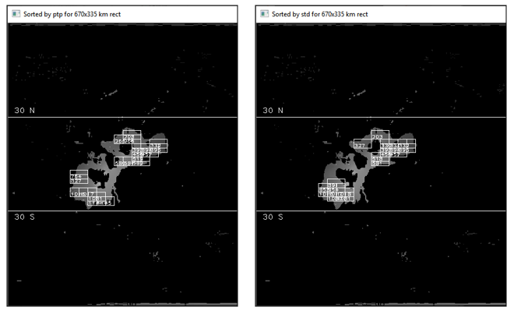

Figure 7-19: Filtered MOLA map over the Tharsis Montes region, with ptp (left) and std (right) rectangles

You can find the geological map, Mars_Global_Geology_Mariner9_1024.jpg, in the Chapter_7 folder, downloadable from the book’s website. The volcanic deposits will be light pink in color. A solution, practice_geo_map_step_1of2.py and practice_geo_map_step_2of2.py, can be found in the same folder and in the Appendix. Run the practice_geo_map_step_1of2.py program first to generate the filter for step 2.

Practice Project: Extracting an Elevation Profile

An elevation profile is a two-dimensional cross-sectional view of a landscape. It provides a side view of a terrain's relief along a line drawn between locations on a map. Profiles can be used to study the smoothness of a surface and to help people visualize topography. For this practice project, draw a west-to-east profile that passes through the caldera of the largest volcano in the solar system, Olympus Mons (Figure 7-20).

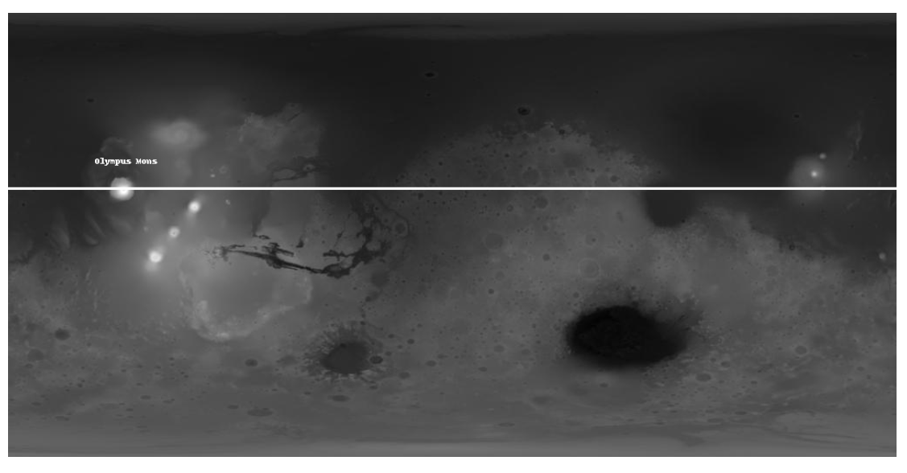

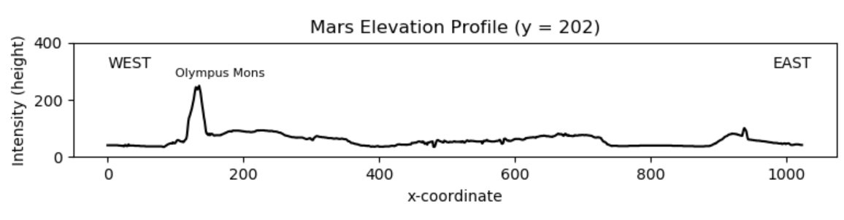

Figure 7-20: Vertically exaggerated west-east profile through Olympus Mons

Use the Mars MGS MOLA - MEX HRSC Blended DEM Global 200m v2 map shown in Figure 7-20. This version has better lateral resolution than the one you used for Project 10. It also uses the full elevation range in the MOLA data. You can find a copy, mola_1024x512_200mp.jpg, in the Chapter_7 folder downloadable from the book’s website. A solution, practice_profile_olympus.py, can be found in the same folder and in the Appendix.

Practice Project: Plotting in 3D

Mars is a very asymmetrical world, with the southern hemisphere dominated by ancient cratered highlands and the north by smooth flat lowlands. To make this more apparent, use the 3D plotting functionality in matplotlib to display the mola_1024x512_200mp.jpg image you used in the previous practice project (Figure 7-21).

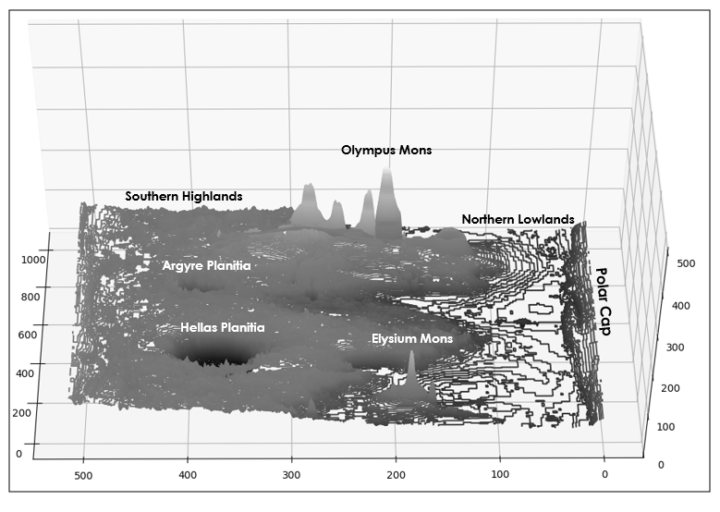

Figure 7-21: A 3D contour plot of Mars, looking toward the west

With matplotlib, you can make 3D relief plots using points, lines, contours, wireframes, and surfaces. Although the plots are somewhat crude, you can generate them quickly and use the mouse to interactively grab the plot and change the viewpoint. They are particularly useful for those who have trouble visualizing topography from 2D maps.

In Figure 7-21, the exaggerated vertical scale makes the elevation difference from south to north easy to see. It’s also easy to spot the tallest mountain (Olympus Mons) and the deepest crater (Hellas Planitia).

You can reproduce the plot in Figure 7-21—sans annotation—with the practice_3d_plotting.py program in the Appendix and in the Chapter_7 folder downloadable from the book’s website. The map image can be found in the same folder.

Challenge Project: Making it Three in a Row

Edit the previous Practice Project so that the profile passes through the three volcanos on Tharsis Montes, as shown in Figure 7-22.

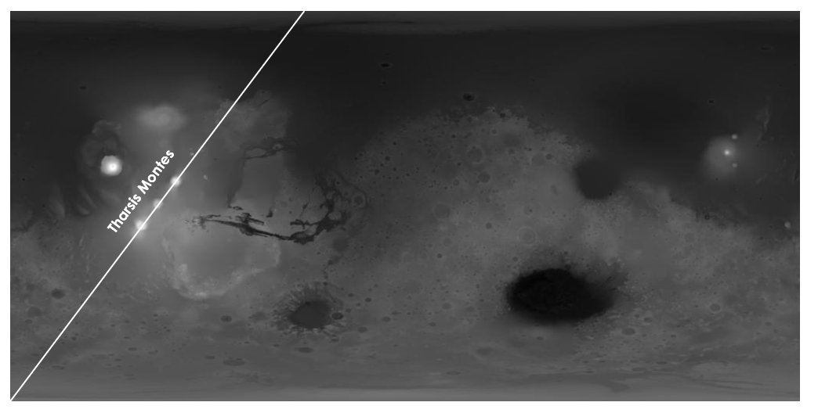

Figure 7-22: Diagonal profile through the three volcanoes on Tharsis Montes

As you probably know by now, no solutions are provided for challenge projects.

Challenge Project: Wrapping Rectangles

Edit the code for Project 10 so that it accommodates rectangle dimensions that don’t divide evenly into the width of the MOLA image. One way to do this is to add code that splits the rectangle into two pieces—one along the right edge of the map and the other along the left edge—calculates statistics for each, then recombines them into a full rectangle. Another approach is to duplicate the image and “stitch” it to the original image as shown in Figure 7-23. This way, you won’t have to split the rectangles, just decide when to stop stepping them across the map.

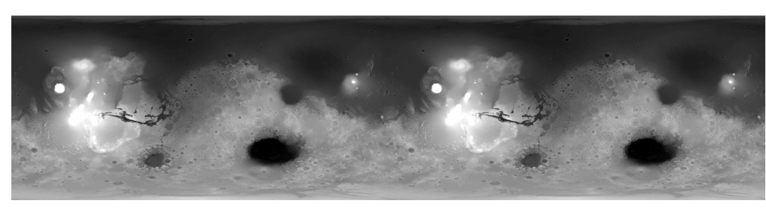

Figure 7-23: The grayscale MOLA image duplicated and repeated